Capstone Project  
  
1) Angular Admin + Client Side  
Doing a login system that allows for different use roles allows for users and admins to go through the same system and receive different endpoints, including a different navbar and features.

When logging in as an admin, you will get more features such as the ability to register new users and add restaurants (and dishes)

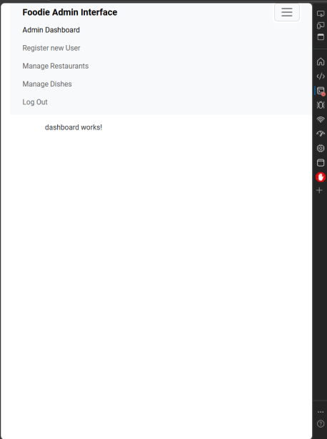

Add Dish

Footer Shows Successful Creation

Successfully written into backend

Add Restaurant

Footer confirms successful creation

Appears in the mySQL backend

Generating auth guard for admin

Auth-guard.ts (Will add more authentication when backend is made)

Login as Admin:

2) Angular User Side

User side has no management system or option to create additional users. This is accessed by logging in via an account that has UserRole = customer instead of admin.

Admin accounts cannot be created in registration.

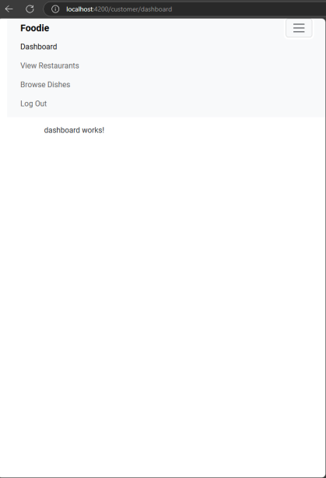

View Dishes

View Restaurants

3) Database SQL:  
  
CREATE DATABASE foodie;

USE foodie;

CREATE TABLE Restaurants (

id BIGINT AUTO_INCREMENT PRIMARY KEY,

name VARCHAR(255) NOT NULL,

location VARCHAR(255) NOT NULL

);

CREATE TABLE Dishes (

id BIGINT AUTO_INCREMENT PRIMARY KEY,

name VARCHAR(255) NOT NULL,

price DECIMAL(10, 2) NOT NULL,

restaurant_id BIGINT,

FOREIGN KEY (restaurant_id) REFERENCES Restaurants(id) ON DELETE CASCADE

);  
  
Database Test Data  
  
INSERT INTO Restaurants (name, location) VALUES

('Greasy Grove', 'Manchester'),

('Pizza Place', 'Manchester'),

('Sushi Shop’, 'Leeds'),

('Tomato Town', 'Leeds’);  
  
INSERT INTO Dishes (name, price, restaurant_id) VALUES

('Beef Burger', 2.99, 1),

('Cheeseburger', 3.99, 1),

('Pepperoni Pizza', 9.99, 2),

('Veggie Pizza', 8.99, 2),

(‘California Roll’, 4.99, 3),

('Edamame', 1.99, 3),

('Penne Pasta', 1.99, 4),

('Spaghetti Bolognaise', 3.99,4);

Test Queries

4) Spring Boot Java Backend

Initialise spring boot

When ran, users generated in MYSQL

Dishes + Restaurants created on springboot backend rather than SQL File:

